SUMMER SCHOOL Simulation in Nursing Education

------------------------------------------

https://www.fzv.um.si/en/summer-school-simulation-nursing-education

The new Erasmus+ programme (2021-2027) introduces new Blended Intensive Programmes (BIP) as alternative mobility for students. The University of Maribor, Faculty of Health Sciences, is organising a SUMMER SCHOOL Simulations in Nursing Education for nursing students in the period 09.09.-16.09.2022 (3 ECTS) with NO FEE for participants.
BIP combines short-term physical mobility with a virtual component and makes the Erasmus mobility more flexible. Students who participate in BIP can maintain their study plans at their home institution and include BIP as a parallel activity. Short-term online (1 day) and physical mobility (one week in Slovenia) will constitute the only period outside their home institution. Therefore, students should credit the BIP to their study plans, as in the case of traditional Erasmus mobility.
The sending institution’s International Relations offices will provide information and support to students for physical mobility.
Students will receive support for physical mobility: 70 Eur per day. Students with fewer opportunities may receive travel support. Students who do not receive travel support can opt for green travel. In this case, they will receive a single contribution of 50 EUR as a top-up amount to the individual support and up to 4 days of additional individual support to cover travel days for a return trip, if relevant.
We live in a time of great social change, largely due to the development of political, economic and population factors. Nurses are important members of broader health and multidisciplinary team in the holistic and quality treatment of patients for health and well-being. At the same time, additional education, continuous improvement and monitoring of the progress of knowledge are becoming increasingly important for nurses. Simulations in nursing education represent an effective method of learning and teaching. They offer nursing students the opportunity to hone clinical skills in a controlled and safe environment based on critical thinking. The combined intensive training program offers nursing students theoretical and practical training based on simulations.
They will discuss communication in the healthcare team and in relation to the patient and relatives, understanding and applying the concepts of improving quality and safety in healthcare, basic and advanced resuscitation procedures, and predicting and dealing with serious medical conditions. In the first part, which will take place online, they will get to know each other and present teaching and learning in simulation environments in each participating country and their health system. This will be followed by online lectures by foreign and domestic experts, which will introduce them to various skills that are essential for everyday practice in the profession. In the second part, which will take place at the Faculty of Health Sciences University of Maribor, they will be able to train on puppets in the simulated environment of the Simulation Centre and the Simulation Center Ljubljana. Simulations allow students to train in a safe environment, as any mistakes do not result in harm to patients. They will confirm and test their knowledge at the end of an intensive program with self-reflection and debriefing with a clinical mentor, where they will learn about their strengths and weaknesses based on recorded scenarios.
The summer school will take place in English language and not only offers students excellent content, but also strives for an unforgettable stay in Maribor and Slovenia. Students will also enjoy a variety of social activities, providing an opportunity for professional and interpersonal networking.
Students can apply until July 15th 2022.
The maximum number of participants in BIP is limited to 20. All applicants will receive the information on admission to the course before July 22nd 2022.
Contact person:
Aleksandra Lovrenčič, aleksandra.lovrencic@um.si
Calendar:
Virtual event: September 9th 2022
Physical event starting September 12th ending September 16th 2022, in Maribor, Slovenia.
The accommodation reservation
Accommodation and travel costs for the physical event in Maribor are covered by participants (please check with the home institution on the Erasmus grant for BIP). The University of Maribor will provide all participants accommodation at the Student Dormitory.
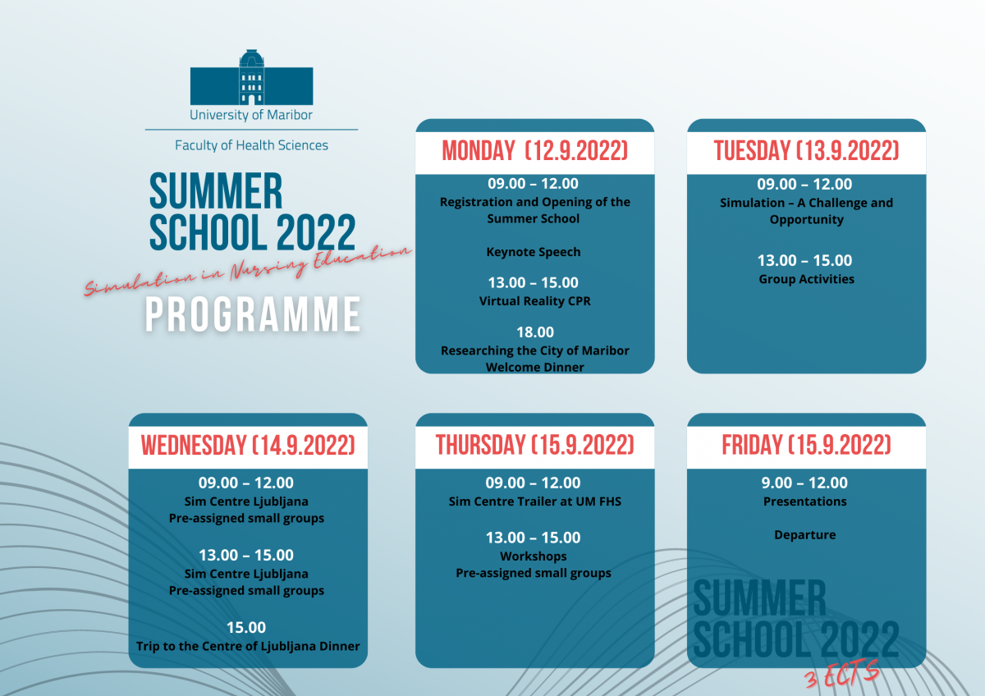

ONLINE APPLICATION FORM
https://forms.office.com/pages/responsepage.aspx?id=TkbxjrYonUSVvuZp7j0IrDOfzcQK81xHnoK7-zoiodFURVpDM0Y3OU9QQzdFMU5DTklZVEFPTlVNUiQlQCNjPTEu

